PYTHON INSTALLATION

1. Open official website to download python, by searching on google and open a link on the result.
2. Click on download latest version of python on my pc.
3. Opening the download folder and right click on python and run as administrator.
4. Choosing customize installation and choose different feature to be installed..

On advanced option changing installation folder to to program files(86) and click on next to install until finish. And click on close.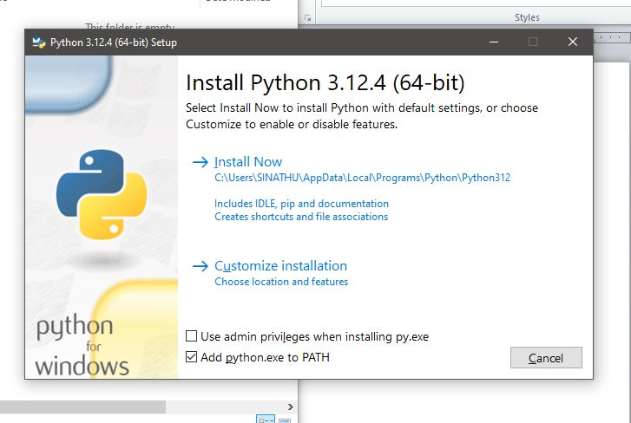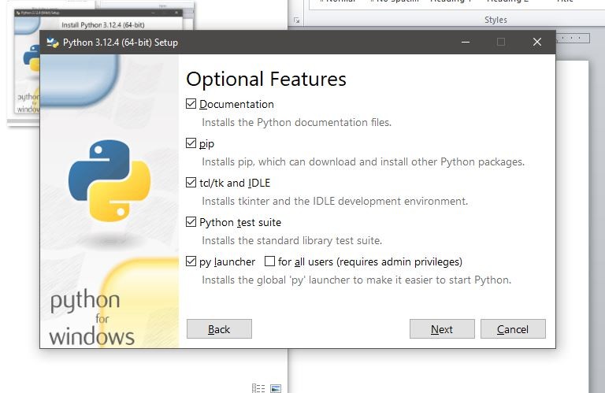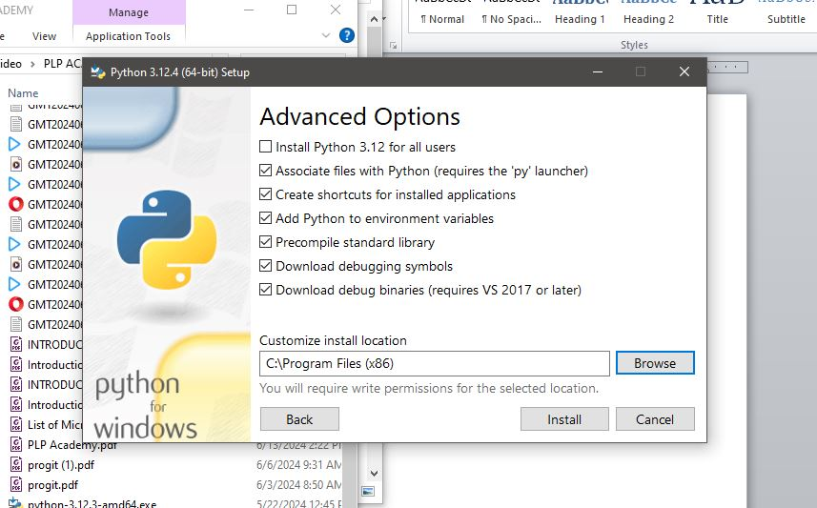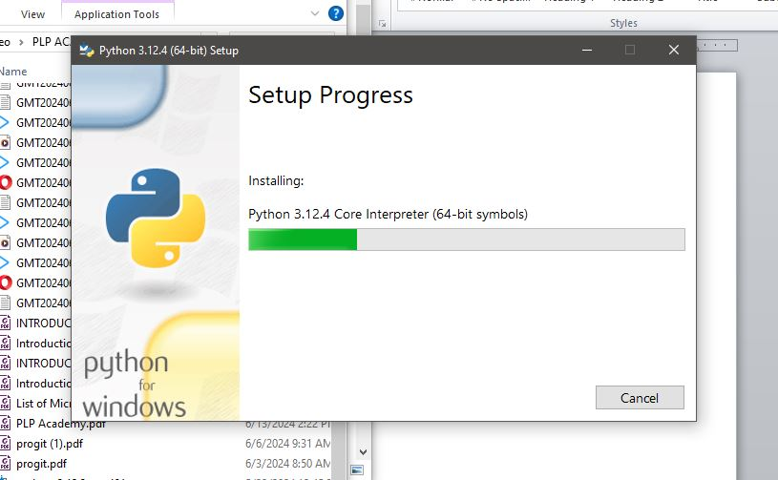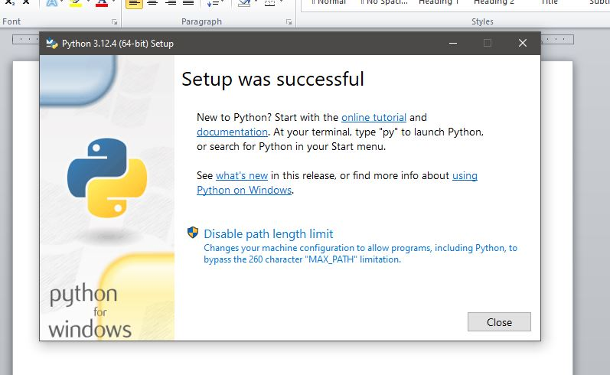

VS CODE INSTALLATION

1. Download Vscode from official website.
2. Click on downloaded files form download folder to start installation.
3. Accept agrrement and click next and choose installation directory, then next and choose create desktop icon.
4. Opening vscode and install some extension to be used later,